# IOT BASED SAFETY GADGET FOR CHILD

# SAFETY MONITORING AND NOTIFICTION.

**TEAM ID : PNT2022TMID44697**

**TEAM LEADER : GRACERANI M**

**TEAM MEMBERS : ELAKKIYA S (732519104005)**

**GRACERANI M (732519104007)**

**PAVITHRA M (732519104704)**

**SUMITHRA A (732519104501)**

**DEPARTMENT : COMPUTER SCIENCE AND**

**ENGINEERING**

**COLLEGE NAME : SHREE VENKATESHWARA HI-TECH**

**ENGINEERING COLLEGE,**

**GOBI.**

**PROPOSED SYSTEM**

The child safety wearable device is capable of acting as a smart IoT device. It provides parents with the real –time location, surrounding temperature, UV radiation index and SOS light along with Distress alarm buzzer for their child’s surrounding’s and the ability to locate their child or alert bystanders in acting to resource or comfort the child. The smart child safety wearable can be enhanced much more in the future by using highly compact Arduino modules such as the LilyPad, Arduino which can be sewed into fabries. Also a more power efficient model will have to be created which will be capable of holding the battery for a longer time.

**NOVELTY:**

The novelty of the work is that the system automatically alerts the parent’s/caretaker by sending SMS, when immediate attention is required for the child during emergency. Parent’s and also the institution can keep track of children from home to school till school to home.

**FEASIBILITY SOF IDEA :**

* Research on child abuse interventions is highly needed.
* Safer child is a parenting program delivered quickly after a report of child abuse.
* The intervention was successfully implemented with in the social services.
* Safer child- parents were reported again to a lower extent than control group families.
* The effects of safer child need to be further evaluated in larger trials.

**BUSINESS MODEL :**

* Product quality is a significant trend that is expected to have an impact on organic growth throughout the forecast, governments are enacting stricter rules and regulation need a through testing. Another trend projected to drive the market throughout the forecast period is the introduction of unique and multi-functionality in baby strollers.
* The offline distribution channel held the largest share of more then 70.0% in 2018.The major players in the baby safety products market are generating maximum revenue from offline sales.
* Technological advancement has introduced devices such as baby monitors that enable real-time communication between parents and babies.

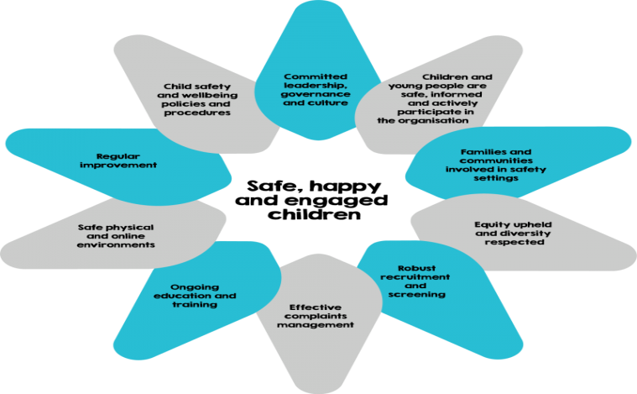

**SOCIAL IMPACT :**

* Mental health disorders such as anxiety, attachment, post-traumatic stress and depression disorders.
* Self-harming or suicidal thoughts, learning disorders, including poor language and cognitive development, developmental delay, eating disorders and physical ailments.
* Child maltreatment can cause excessive or prolonged activation of stress response systems in the body and brain, known as toxic stress.
* Toxic stress can have lifelong, damaging effects on learning, behavior,

And health.

* While children from all backgrounds deal with adverse experiences and toxic stress, child growing up in minority communities are often subject to more in comparison.

**SCALABILITY OF SOLUTION :**

The key to scaling child protection is breaking out of long-established silos. Child protection should not work alongside health- it is key to ensuring better health. Child protection should not occur in parallel to education- it is a principal contributor to better attendance and learning outcomes, child protection is not ancillary to social protection- it promotes better cognitive, emotional, and social development outcomes. Child protection is not just about the enforcement of laws- it improves social cohesion and prevents children from coming with the law, child protection becoming a central and cross-sector feature of country development plans is one step towards making these changes.